Unmet Health Care Needs:
Where Are They?

Where are they, indeed?

If we want to see how other areas of the region fare in perception of unmet health care needs compared to Halifax, we can establish Health Region 6 as the benchmark or reference group and map the deviations from that reference group using ArcView and the CCHS data.

1. Begin by unzipping the contents of HealthBoundaries.zip in C:\CCHS.

2. Next, start an ArcGIS session by double-clicking on the ArcView icon on your desktop. You will normally be greeted with a Welcome screen. Accept the default option:  “Create a new project  - with a new view.” | 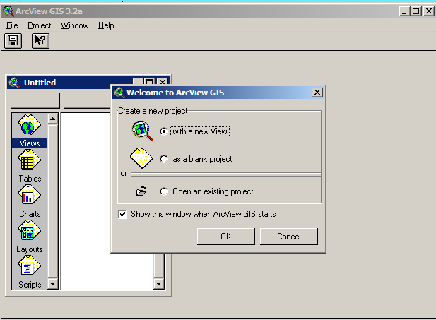
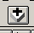
Tip: If you miss the Welcome box, simply click on FILE→NEW PROJECT. Then, click on the NEW button which will bring up a New View box open. Click on the plus symbol on the toolbar to bring up the dialogue box below, to add a theme.

3. You will be asked if you want to add data to the view now.  Click YES and navigate to the directory containing the ArcView shape file:  C:\CCHS\healthboundaries\atl_hr.shp | 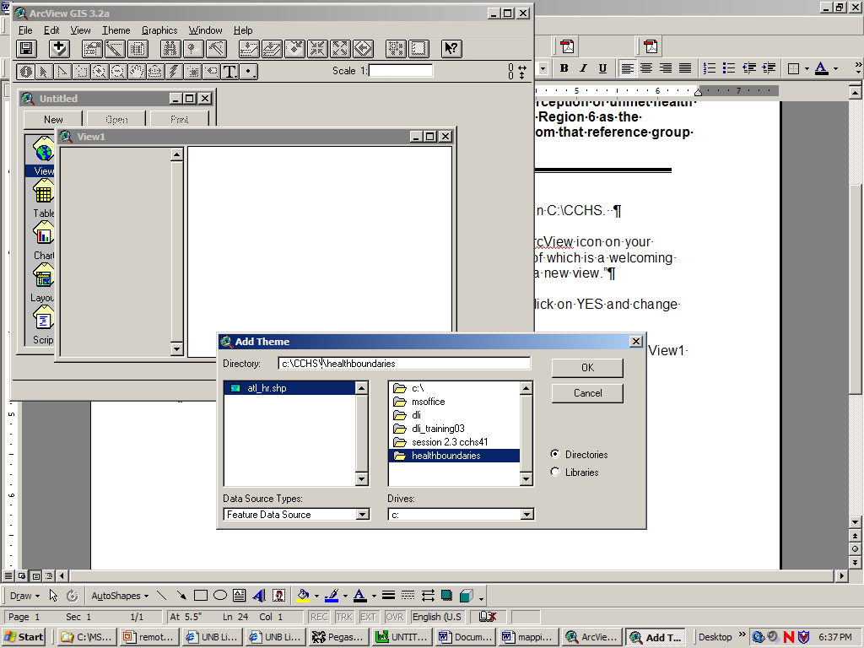

 | 4. All that is needed now is a check mark in the box, as indicated, to turn the theme on.    Hey, that is looking good! |  | 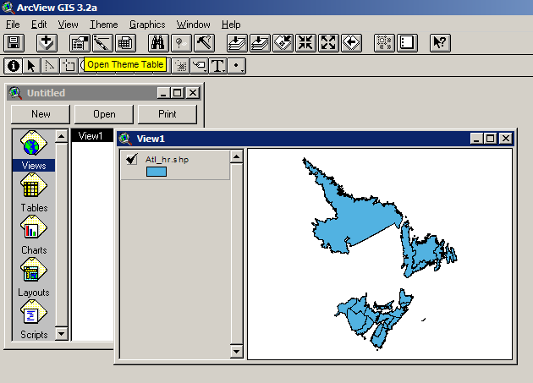
5. To see the attribute table behind this geographic file, ensure that the theme is active (it looks raised or embossed when active) and click on the toolbar button,  Open Theme Table  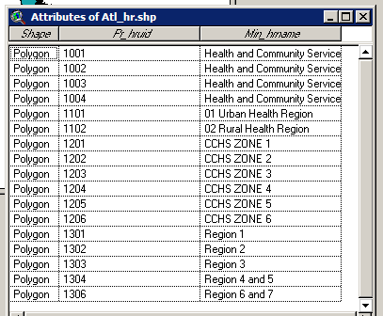 |  | 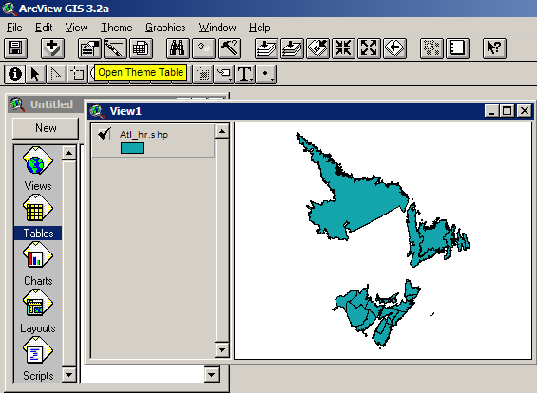

6. We need to bring in the results of our work with the CCHS file now. Highlight the button marked TABLE.  Then click on the ADD button which will produce another dialogue box. Navigate to the directory in which you saved the CCHS dbase table and click OK:  C:\CCHS\AtlanticCCHS.dbf. | 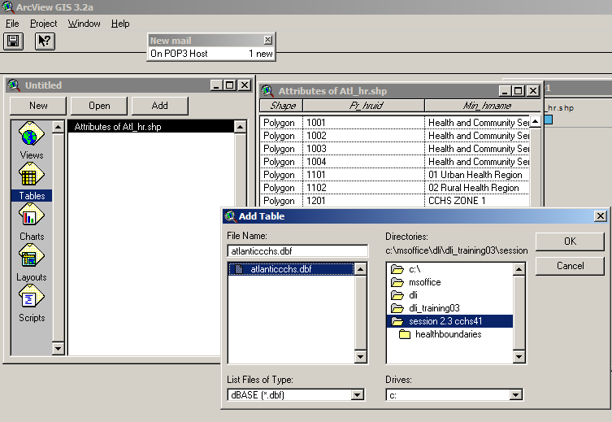

7. You should now see two tables on the screen.  Take a closer look.  What has happened to New Brunswick Health Region 6 and 7?  We will want to make the two tables agree on what to call this united group! | 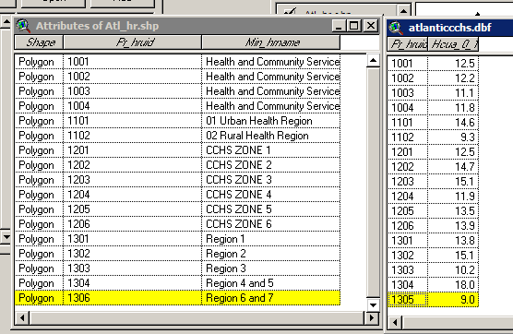

8. Click on the table for Atl_hr.shp. Go to the menu bar and select  Table→start editing  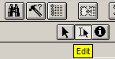  Turn on the EDIT button  In the column Pr_hruid, click on 1306 Change the number to 1305 and click in another box to “lock” the change.  Go back up to the menu bar and select “Stop editing”.  You will be asked if you wish to save edits. Say yes. | 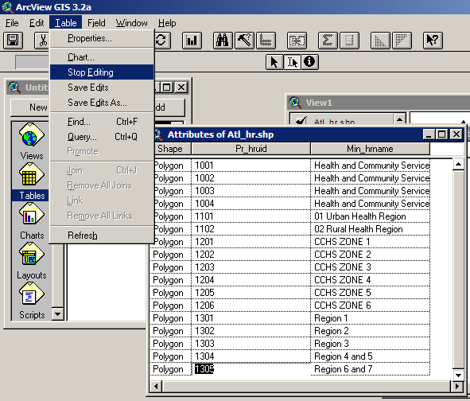

9. We are now ready to merge the two tables.  For convenience, arrange the tables so that the Atl_hr.shp is on the left side of your screen and the AtlanticCCHS.dbf is on the right.  In both tables, highlight the field we will use to join the tables: PR_hruid.  Click on the Atl_hr.shp table to make it the destination table, and press the join (kissy-face) button. | 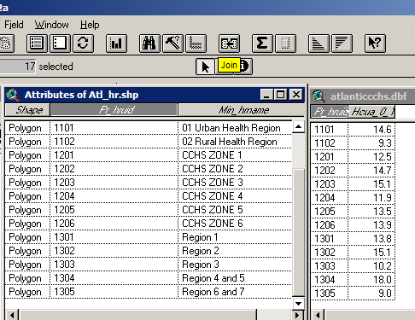
Presto! The AtlanticCCHS.dbf table disappears and, if you scroll across the columns, you will see that Atl_hr.shp has an additional column.

10. To map our variables, we need the Legend Editor. Make the map visible by clicking on the View 1 window, and double-click on the coloured box. This should open the Legend Editor dialogue box.

Change the Legend Type using the drop-down menu to “Graduated Color”.

Using the Classification Field drop-down menu, select HCUA_0_1

Now Chuck, being the data guy that he is, could not bear to give us just a normal view of the world, accepting defaults at every turn.

Nope.

He took the standard deviation of the percentages and selected hand-defined intervals. How? He rounded the standard deviation to 2.4 percent and divided this by two. From the percentage from NS HR6, he subtracted 1.2 percent, which gave the left-bound of the interval for NS HR 6 (the interval being 12.7 to 15.1). The next two lower intervals range from (10.3 to 12.6) and (7.9 to 10.2). The two intervals above the reference group are (15.2 to 17.5) and 17.6 to 19.9).

As Leo might say at this point:
“It is a Far Side Moment…

It is easier to do it. Click in each column under value and change the numbers to read as indicated below. When you are done, click on the APPLY button.

And, if you don’t like the colours chosen for you by ArcView, use the Color Ramps to change the view of the world—Atlantic Style!



