

What’s the scoop on …

FTP Census Geography

What do you need to know to navigate through the FTP Census Geography site?

First, know this:

Every census team has come up with a different way to present their products in their directory structure. So the directories have no apparent order or consistency to them. They use codes, without a magic decoder ring on the site. And feedback from users has changed the products themselves over time.

Six Questions to Find Your Way

There are six questions which, if you keep in mind, can help you navigate your way to the files you need for your user.

At some point in the directory listing, you will be asked:

- What product do I want?

Do you need a reference tool such as Geosuite? A catalogue of geography products? A postal code conversion file? Or, as we will assume here, a file that can be used with ESRI products to provide boundaries for the country-a spatial file?

At some point in the directory listing, you will be asked:

- What language do I prefer?

Canada is bilingual and though spatial points are generally non-linguistic, the names attached to the point can be in either official language.

At some point in the directory listing, you will be asked:

- What software format do I need?

DLI supports both MapInfo and ESRI (eg ArcView, ArcMap) products, comparable to SPSS and SAS in the data world . We will assume here that we want an ESRI compatible file and will be keeping our eyes out for the word “ArcInfo”.

At some point in the directory listing, you will be asked:

- What layers or coverage do I require?

Do you want just boundaries? Or do you need coastline information? Rivers and lakes? What about roads? Because many of these layers are listed by abbreviation only, please refer to the Appendix when confronted with a puzzling decision, such as whether to use SNF or SSNF files.

At some point in the directory listing, you will be asked:

- What geographical hierarchy do I need?

Are you mapping the national? Or the province? Do you need detailed geographic areas such as EA/DAs?? Or do you need Census Tracts, which are found only in designated CMAs and CAs.

An understanding of the geographic hierarchy used in the census, and a key to abbreviations used over time will help immensely in deciding which subdirectory to explore. Both hierarchy and abbreviations can be found in the Appendix to this guide. For example, in 2001, these were your choices, within subdirectories.

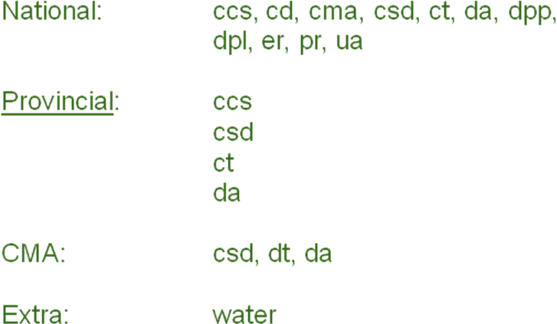

At some point in the directory listing, you will be asked:

- Which file do I need?

In some years, census geography uses proper names; in other years, they use geographic codes. The most frequently used at the file name level are provincial codes and CMA/CA codes. These are included in the Appendix.

APPENDIX A

Helpful Information: Codes and Abbreviations

PROVINCES
10 Newfoundland  11 PEI  12 NS  13 NB  24 QU  35 ON  46 MN | 47 SK  48 AB  59 BC  60 YU  61 NWT  62 NU

CENSUS METROPOLITAN AREAS / CENSUS AGGLOMERATIONS

CA/CMAs—Atlantic
  001 | St. John's | CMA
  005 | Bay Roberts | CA
  010 | Grand Falls-Windsor | CA
  015 | Corner Brook | CA
  105 | Charlottetown | CA
  110 | Summerside | CA
  205 | Halifax | CMA
  210 | Kentville | CA
  215 | Truro | CA
  220 | New Glasgow | CA
  225 | Cape Breton | CA
  305 | Moncton | CMA
  310 | Saint John | CMA
  320 | Fredericton | CA
  328 | Bathurst | CA
  329 | Miramichi | CA
  330 | Campbellton | CA
  335 | Edmundston | CA
  330 | Campbellton | CA

CA/CMAs—Quebec
  403 | Matane | CA
  404 | Rimouski | CA
  405 | Rivière-du-Loup | CA
  406 | Baie-Comeau | CA
  408 | Saguenay | CMA
  410 | Alma | CA
  411 | Dolbeau-Mistassini | CA
  412 | Sept-Îles | CA
  421 | Québec | CMA
  428 | Saint-Georges | CA
  430 | Thetford Mines | CA
  433 | Sherbrooke | CMA
  437 | Cowansville | CA
  440 | Victoriaville | CA
  442 | Trois-Rivières | CMA
  444 | Shawinigan | CA
  446 | La Tuque | CA
  447 | Drummondville | CA
  450 | Granby | CA
  452 | Saint-Hyacinthe | CA
  454 | Sorel-Tracy | CA
  456 | Joliette | CA
  459 | Saint-Jean-sur-Richelieu | CA
  462 | Montréal | CMA
  465 | Salaberry-de-Valleyfield | CA
  468 | Lachute | CA
  480 | Val-d'Or | CA
  481 | Amos | CA
  485 | Rouyn-Noranda | CA

CMA/CAs-Ontario

  502 | Hawkesbury | CA
  505 | Ottawa--Gatineau | CMA
  501 | Cornwall | CA
  502 | Hawkesbury | CA
  505 | Ottawa--Gatineau | CMA
  512 | Brockville | CA
  515 | Pembroke | CA
  516 | Petawawa | CA
  521 | Kingston | CMA
  522 | Belleville | CA
  527 | Cobourg | CA
  528 | Port Hope | CA
  529 | Peterborough | CMA
  530 | Kawartha Lakes | CA
  531 | Centre Wellington | CA
  532 | Oshawa | CMA
  533 | Ingersoll | CA
  535 | Toronto | CMA
  537 | Hamilton | CMA
  539 | St. Catharines--Niagara | CMA
  541 | Kitchener | CMA
  543 | Brantford | CMA
  544 | Woodstock | CA
  546 | Tillsonburg | CA
  547 | Norfolk | CA
  550 | Guelph | CMA
  553 | Stratford | CA
  555 | London | CMA
  556 | Chatham-Kent | CA
  557 | Leamington | CA
  559 | Windsor | CMA
  562 | Sarnia | CA
  566 | Owen Sound | CA
  567 | Collingwood | CA
  568 | Barrie | CMA
  569 | Orillia | CA
  571 | Midland | CA
  575 | North Bay | CA
  580 | Greater Sudbury | CMA
  582 | Elliot Lake | CA
  584 | Temiskaming Shores | CA
  586 | Timmins | CA
  590 | Sault Ste. Marie | CA
  595 | Thunder Bay | CMA
  598 | Kenora | CA

CMA/CA Prairie Provinces

  602 | Winnipeg | CMA
  607 | Portage la Prairie | CA
  610 | Brandon | CA
  640 | Thompson | CA
  705 | Regina | CMA
  710 | Yorkton | CA
  715 | Moose Jaw | CA
  720 | Swift Current | CA
  725 | Saskatoon | CMA
  735 | North Battleford | CA
  745 | Prince Albert | CA
  750 | Estevan | CA
  840 | Lloydminster | CA
  805 | Medicine Hat | CA
  806 | Brooks | CA
  810 | Lethbridge | CA
  820 | Okotoks | CA
  825 | Calgary | CMA
  828 | Canmore | CA
  830 | Red Deer | CA
  833 | Camrose | CA
  835 | Edmonton | CMA
  840 | Lloydminster | CA
  845 | Cold Lake | CA
  850 | Grande Prairie | CA
  860 | Wood Buffalo | CA
  865 | Wetaskiwin | CA

CMA/CAs-British Columbia & North
  905 | Cranbrook | CA
  913 | Penticton | CA
  915 | Kelowna | CMA
  918 | Vernon | CA
  920 | Salmon Arm | CA
  925 | Kamloops | CA
  930 | Chilliwack | CA
  932 | Abbotsford | CMA
  933 | Vancouver | CMA
  934 | Squamish | CA
  935 | Victoria | CMA
  937 | Duncan | CA
  938 | Nanaimo | CA
  939 | Parksville | CA
  940 | Port Alberni | CA
  943 | Courtenay | CA
  944 | Campbell River | CA
  945 | Powell River | CA
  950 | Williams Lake | CA
  952 | Quesnel | CA
  955 | Prince Rupert | CA
  960 | Kitimat | CA
  965 | Terrace | CA
  970 | Prince George | CA
  975 | Dawson Creek | CA
  977 | Fort St. John | CA
  990 | Whitehorse | CA
  995 | Yellowknife | CA

ABBREVIATIONS

CBF | Cartographic Boundary File | Cartographic Boundary Files (CBFs) contain the boundaries of standard geographic areas together with the shoreline around Canada and the larger inland lakes, all integrated in a single layer. The Cartographic Boundary Files for 2001 replace the Digital Cartographic Files. Two versions of the Cartographic Boundary Files (CBF) were produced for the 2001 Census. The initial version contained an integrated water layer with the boundaries that work well for cartographic mapping applications but could not satisfy user needs for use in geocoding operations. The second version released separated the water layer from the boundaries and could be used for cartographic and geocoding applications.
DBF | Digital Boundary File | Digital Boundary Files (DBF) display the official boundaries used for Census collection and, therefore, often extend as straight lines into bodies of water.
DCF | Digital Cartographic File | Unlike the DBF, Cartographic Boundary Files (CBF) are modified to follow the coastlines and shorelines on the perimeter of Canada's land mass, including major islands.
CA | Census Agglomeration | Census agglomerations (CAs) are centred on urban cores with populations of at least 10,000
CAR | Census Agricultural Regoin | A census agricultural region is a sub-provincial geographic area used primarily by the Census of Agriculture for disseminating agricultural statistics. In most provinces, census agricultural regions usually comprise groups of adjacent census divisions. in Prince Edward Island, each of the three existing census divisions (counties) is treated as a census agricultural region for data dissemination purposes.
CCS | Census Consolidated Subdivision | A Census Consolidated Subdivision (CCS) is a grouping of two or more Census Subdivisions (CSDs), where a CSD is an incorporated town or municipality.
CD | Census Divisions | This is a general term applying to areas established by provincial law, which are intermediate geographical areas between the municipality (census subdivision) and the province.
CMA | Census Metropolitan Area | A CMA is delineated around an urban core with a population of at least 100,000, based on the previous census.
CSD | Census Subdivision | This is a general term applying to municipalities (as determined by provincial legislation) or their equivalents, e.g., Indian reserves, Indian settlements and unorganized territories. Municipalities are units of local government.
DA | Dissemination Area | A dissemination area (DA) is a small area composed of one or more neighbouring blocks. DAs cover all of Canada and replace enumeration areas (EAs) as the smallest standard geographic areas for which all census data are disseminated
DPL | Designated Place | A designated place (DPL) is usually a small community that does not meet the criteria used to define municipalities or urban areas. DPLs may straddle census subdivision (CSD) boundaries.
EA | Enumeration Area | The geographic area canvassed by one census representative. It is the smallest standard geographic area for which census (1996 and previous) data are reported. All the territory of Canada is covered by EAs
ER | Economic Region | Economic Regions (ER) are geographical units suitable for the presentation and analysis of regional economic activity. Generally, they are made up by grouping whole census divisions. ERs may be economic, administrative or development regions
FED |  | A federal electoral district is an area represented by a member of Parliament (MP) elected to the House of Commons
FSA |  | geographical units defined by Canada Post Forward Sortation Area (FSA). This part of the postal code indicates the greater region where the mail has to be delivered
UA |  | An urban area (UA) has a minimum population concentration of 1,000 persons and a population density of at least 400 persons per square kilometre, based on the current census population count.
RNF |  | Road Network File (RNF) contains roads, road names and address ranges (arc or line attributes) for the entire country. Most commonly, address ranges are dwelling-based and are mainly available in the large urban centres of Canada.. There are 14 standard RNFs: for Canada, the 10 provinces and 3 territories
SNF |  | The SNFs were created from various source maps at different scales, and maintained by the Statistics Canada Geography Division over more than twenty-five years. They contained road names, address ranges and a rich set of road arcs. The SNFs have been incorporated into the information now found in the RNF file.
SSNF |  | Skeletal Street Network Files (SSNFs) exist for areas covered by Street Network Files (SNFs) in all 25 census metropolitan areas (CMAs) and the 15 census agglomerations (CAs) which are included in the census tract program. Skeletal Street Network Files (SSNFs) are “thinned-out” sub-sets of the 1996 Street Network Files (SNF) containing major roads and railways (with street names but no address ranges).

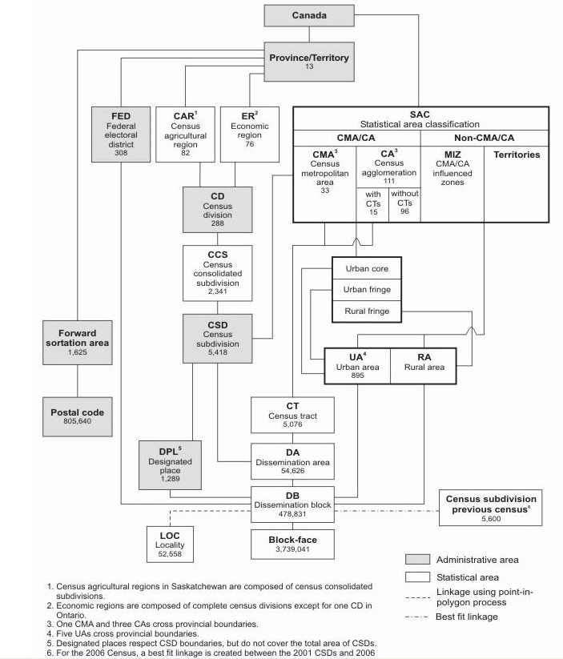
APPENDIX B

Geography Directory Listing (abbreviated)
Census | Directory Structure | Question order
1971 | Geography Attribute Files | [No Spatial Files for Mapping]
1976 | Geography Attribute Files | [No Spatial Files for Mapping]
1981 | ARCINFO  Cd_dr1981.zip  Cma81.zip  Cmaca81.zip  Csd1981_dbf.zip  Csd_sdr1981.zip  Csd_sdr81.zip  Dqsea81_coicou_jonqui.doc  Dqsea81_coicou_jonqui.zip  Prov1981.zip  Sdr1981_dbf.zip  DOCUMENT  GAF  MAPINFO | What software format?  [Arcinfo]  What geographic hierarchy?  Csd_sdr1981.zip
1986 | ARCINFO-86  AGRI  CCS  CD  CMACA  CSD  CSD86.zip  CT  FED  FSA  GRLAKES  POPEC  PROV  DOCUMENTATION  MAPINFO-86  REFERENCE_DATA  Geography Attribute File guide.pdf  Geography Attribute File record layout.pdf | What product / software format?  [Arcinfo]  What geographic hierarchy?  [CSD]
1991 | Dirlist.txt  Readme.txt  DOCUMENT  Geography attribute File guide.pdf  Geography attribute File record layout.pdf  GEOREF91  REFDATA  SPATDATA  ARCINFO  DBF  DCF  CSD  By provincial code  (e.g. g91csd10.exe)  CT  By CMA code  (e.g. g91001.exe)  G91ccs.exe  G91cd.exe  G91csd.exe  G91fed.exe  G91prv.exe  MAPINFO | What product do you need?  [Spatial data]  What software?  [Arcinfo]  What layers? (dbf / dcf)  [Digital cartography file]  What geographic coverage?  [CSD]  What file do you need? (codes)?  [13=New Brunswick]

1996 | BFDF  CONCORDANCE FILES  CORRESPOND  DIGBOUND  DIGCART  DOCUMENT  ENGLISH  ARCINFO  CANADA  BOUNDARY  CCS  CD  CMA  CSD  CT  DPL  EA  F96  FED  FSA  PRE  UA  WATER  CMA  CSD (by CMA codes)  CT (by CMA codes)  EA (by CMA codes)  WATER (by CMA codes)  EXTRA  GENERAL  PROV (by prov codes)  CCS (PROV. CODES)  CSD PROV CODES  CT  EA  WATER  MAPINFO  FRENCH  diggeo.pdf  enggeocat.pdf  FCCP_juin00  FCCP_juin01  FCCP_mai02  FCCP_nov00  FCCP_nov01  FCPCEF_juin00  FCPCEF_juin01  FCPCEF_mai02  FCPCEF_nov00  FCPCEF_nov01  frgeocat.pdf  geo_96-98_municipalboundarieschanges.pdf  geog-attrib-file-96-recordlayout.pdf  geog-attrib-file-96v3.zip  GEOSUITE  INTERIM  PCCF_jun00  PCCF_jun01  PCCF_jun97  PCCF_may02  PCCF_nov00  PCCF_nov01  PCFR _jun00  PCFR _jun01  PCFR _may02  PCFR _nov00  PCFR _nov01  PCPWF  SNFEF  SNFFRR  SSNFFSRR | What product?  [Digital Cartography]  What language?  [English]  What software do you need?  [arcinfo]  What geographic hierarchy?  [Provincial]  What layers do you need?  [CSD]  What file (codes)?  [13=New Brunswick]

2001 | ATTRIBUTE INFO PROD  CARS-FILE  CONCORDANCE  DOCUMENTATION  GEOSUITE  MAPS-CARTES  PCWEIGHT FILE  PCCF  PCFRF  SPATIAL  ARCINFO  ECUMENE PREVIEW  BLOCK-DBF  CBF SECOND EDITION  CMA  CSD (by CMA code)  CT (by CMA code)  DA (by CMA code)  NATIONAL  CCS-SRU  CD  CMACA  CSD  CT  DA  DPL  DPLCSD  ER  FED  FED2003  PR  UA  PROVINCIAL  CCS  CSD  CT  DA  WATER  ECUMENE  FSA BOUNDARY FILE  RNF  SRNF  MAPINFO | What product do you need?  [spatial]  What software?  [arcinfo]  What layer?  CBF  What geographic hierarchy?  Provincial--DAs  What file (codes)?  13=New Brunswick

2006 | CORRESPONDENCE FILES  GEO-DATA-PRODUCTS-GEOSUITE-PCCF  Geo structure 2006-e.pdf  Geo-structure 2006-f.pdf  GEOGRAPHIC REF PRODUCTS MAPS  SPATIAL INFO PRODUCTS MAPINFO ARCINFO GUIDES  ARCINFO  CBF  NATIONAL  CCS  CD  CMA  CSD  CT  DA  DB  DPL  ER  FED  FSA  PR  UA  WATER  PROVINCIAL  AB  DA  DB  WATER  BC  MB  NB.  NS  NT  NU  ON  PE  QC  SK  YT  DBF  ECUMENE  RNF  RNGAF  GUIDES  MAPINFO

