 | Library

LOCATING INFORMATION IN…
PCensus for MapPoint


CBU Library’s PCensus databases provide detailed demographic information for Nova Scotia, and general demographic for Canada and the other provinces.
Use PCensus to:
• Define a geographic area and create a report of the demographic characteristics
• Create τhematic maps with demographic information and graph demographic information
• Create documents containing reports, maps and graphs

PCensus is available on the Library’s workstations. Double click on the PCensus shortcut icons on the computer desktop to open the program.

A. Define a geographic area and create reports, maps or graphs
using MapPoint

1. Start by initiating Microsoft MapPoint North America 2006, in All Programs, in the Start menu. Minimize MapPoint once it is initiated.
2. Click New Project Wizard, and the Study Area Wizard box will display.
3.
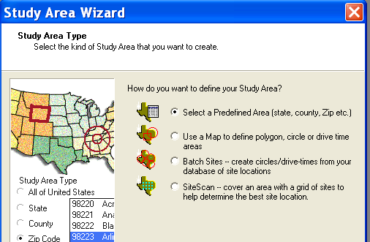
Select Use a Map to make use of the MapPoint functions.
Figure 1: Establishing a Study Area Type

4. Click Next.
5. Select Circle, Polygon, or Drive Time. Circle and Drive Time are the easiest to do.
Polygon is the most difficult, as it involves manipulating the map. Click Next.
6. Choose the means to select your centre point. Address is the easiest. Click Next.
7. Fill in the Address menu. Click Find, then OK. A map and a new menu will appear.
8. Establish a circle radius. Several circles can be created. Example: 0.0 to 1.0 = circle with
1 km radius, 1.0 to 2.0 = ring between 1 and 2 km radius, 0.0 to .5 = circle with .5 km
radius. Click Next. Click on the box to the left of “From [km]” to add more circles
9. Accept or change the Mapped Study Area shape name. Click Next.
10. Select a Demographic Database. Experiment with EAG2008, Daytime Population, E&P. The custom Data Template should be Environics Analytics 2008. Click Finish and Search Now. Clicking on Search Now creates the data display.

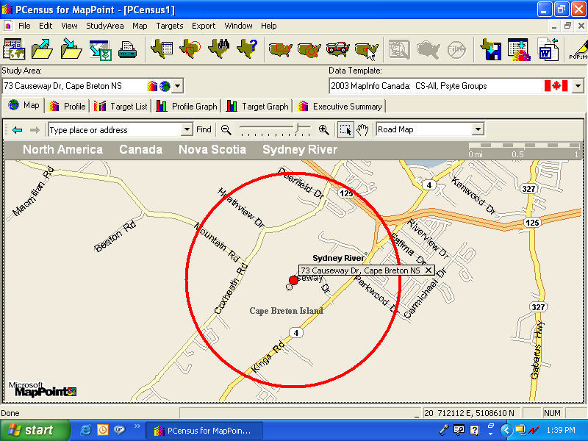
Figure 2: Circle Map of Study Area.
11. Once the search has finished, click Continue. PCensus also gives you the option to construct “target lists” of consumers with specific characteristics and the ability to create thematic maps. For instruction on how to take advantage of this functionality, ask at the Information Desk.

12. To display data, click on the Profile tab or the Profile Graph tab. Remember to choose Map, Profile or Profile Graph for the data or graphic representations of the data.
Also, check the Executive Summary.
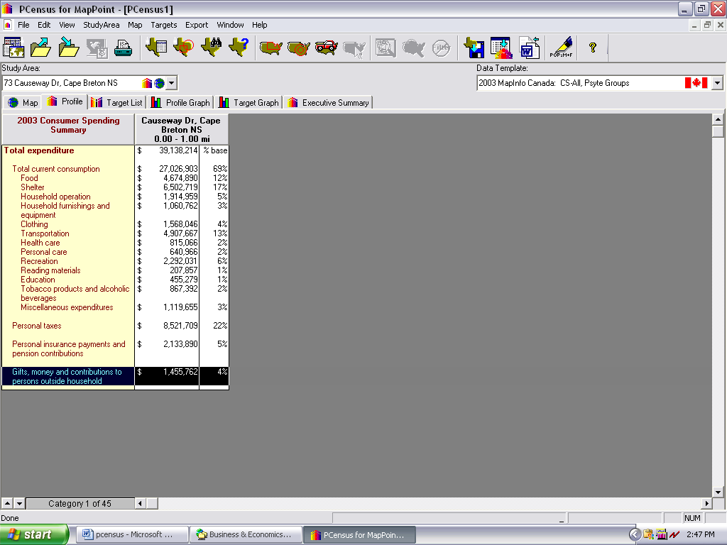  Use the Category button for data  categories | Figure 3: Data for Study Area  12. Click on the MS Word icon on the upper right corner to create a report.  Click the grey Category bar at the bottom left for choices of demographics.
B. Define a predefined study area and create reports, maps or graphs
1. Start by initiating Microsoft MapPoint North America 2006, in All Programs, in the Start menu. Minimize MapPoint once it is initiated.
2. Click New Project Wizard, the Study Area Wizard will display.
3. Click Select a Predefined Area. Click Next.
4. Select a Demographic Database. Try Canada 2006 Census. The Custom Data Template will be Canada Census 2006.
5. Select a Predefined Area such as Forward Sortation Area (FSA). Click Next. Choose the Predefined Area Type.

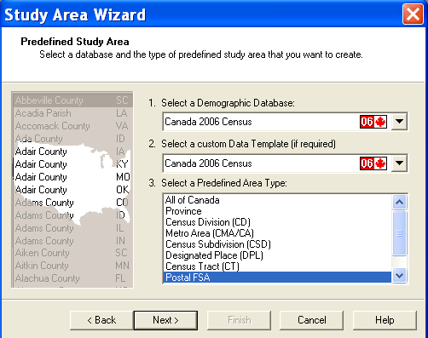Figure 4: Select Predefined Area i.e. FSA

6. Fill in the second template by selecting from the list.
a) To find an area more easily on a long list, type in the first few letters (i.e. Cap to find
Cape Breton within CMA). Designated Place names can be used to find some communities not all individual communities within CBRM. Practice with the options available. Click on your choice to highlight it.
b) Note that if you have selected CSD (Census Subdivision), DA (Dissemination Area),and FSA
(Forward Sortation Area for the first part of a Postal Code) levels, you will have a choice of display options.
c) To choose multiple numbers, hold down the control key while selecting or click the Add Another box. Click Next.
7. Click Next, Finish and Search Now. PCensus also gives you the option to construct “target lists” of consumers with specific characteristics and the ability to create thematic maps. For instruction on how to take advantage of this functionality, ask at the Information Desk.
8. To display data, click on the Profile tab or the Profile Graph tabs. Also, check out the Executive Summary.

C. Printing
1. Select File | Print from the top toolbar. The print menu will appear.
2. The title of the report can be changed at this point.
3. Choose a layout – portrait or landscape. (Note: Up to 4 columns displays well in portrait,
more than 4 columns should be printed in landscape.) The title can be changed. Choose Portrait or Landscape, and columns. Choose what categories to print by holding the CTRL key while selecting. You can choose to print a cover page.
4. Click on Print Selected Categories, select the categories to print from the list provided,
using the CTRL key to select more than one. All categories can be printed at once but each category prints on a separate page and some projects may be many pages. For large files, it is best to export the data to a file.

D. Export data to another program or format
1. Click Export from the top toolbar.
2. Click Export Profile Totals. A menu will appear. Choose All Categories or Selected Categories.
3. Choose a file format. i.e. HTML, Excel,
3. To save the all categories of the project, click All Categories. The default setting is Selected Categories).
4. Choose a file format.
5. Click the Browse button on the right side to choose the desired drive
6. Change the filename as needed, click on Save. The menu will show again.
7. Click OK and the file will save to the desired drive. The default settings will show a preview of the saved file.

